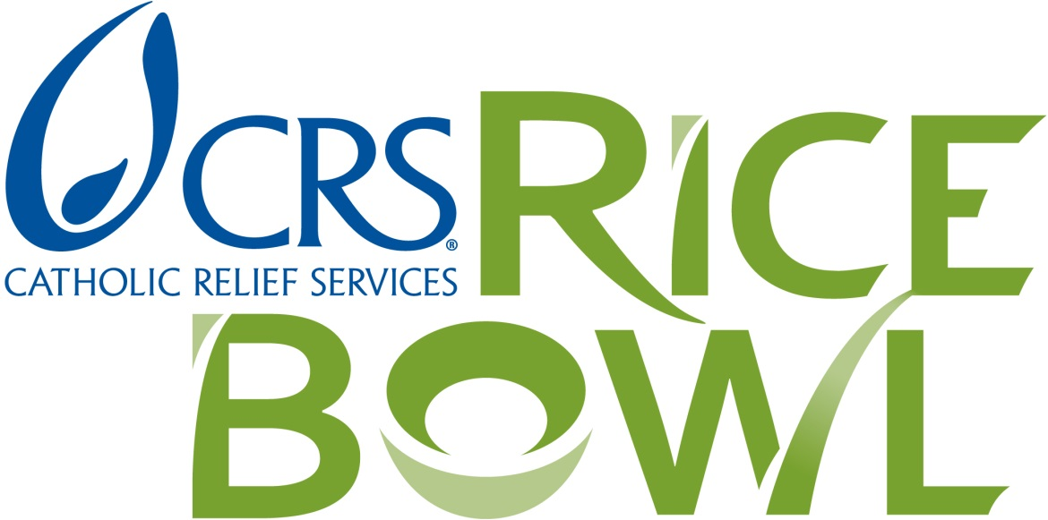

Recipients of the Matthew 25: CRS Rice Bowl Grant
2017

St. Benedict Soup Kitchen – Terre Haute
Cathedral Soup Kitchen – Ss. Peter and Paul Cathedral
Providence Christo Rey High School – Indianapolis
St. Vincent de Paul Church – Warming Center – Bedford
St. Vincent de Paul Society – St. Agnes – Brown County
St. Jude Catholic Church – Food Pantry – Spencer
St. Patrick Parish - Soup Kitchen – Terre Haute
God’s Bounty Food Pantry – Nativity – Indianapolis
Samaritan Food Pantry – Terre Haute
Boulevard Place Food Pantry – Indianapolis
Brown Bag Lunch Project – Terre Haute Deanery Center
Community Diner Inc. – Seymour

